Day #5 – Why doesn’t the government buy the stuff themselves?

Hahaha. Are you perplexed by how easy this seems?

Like most people I would imagine that you have to be shaking your head asking yourself, why don’t they just buy the stuff themselves?

If it is so big, they should save money and just eliminate the little guys, right? Why do they need us?

That is a perfectly good question.

In today’s lesson we will try and answer this all-important mystery.

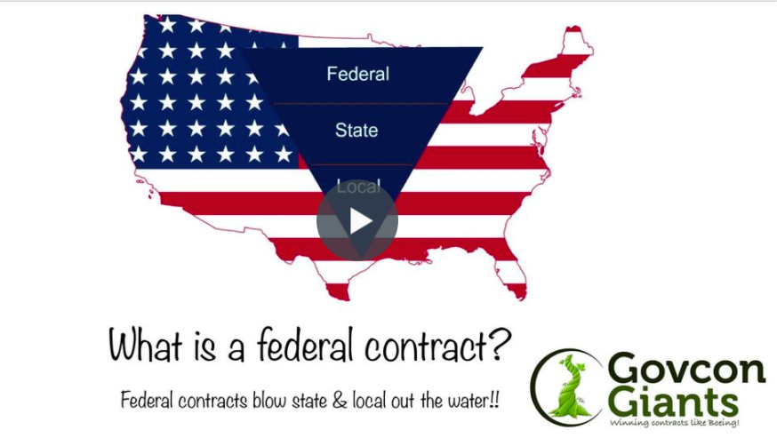

Besides helping strengthen small businesses, remain the backbone of America there are a few more reasons that I can think why the government uses private contractors.

Learn the answers to this question in today’s lesson.

4 Reasons to use Private Contractors

See you manana!

Eric Coffie

